**Build 2 Architectural Diagram**

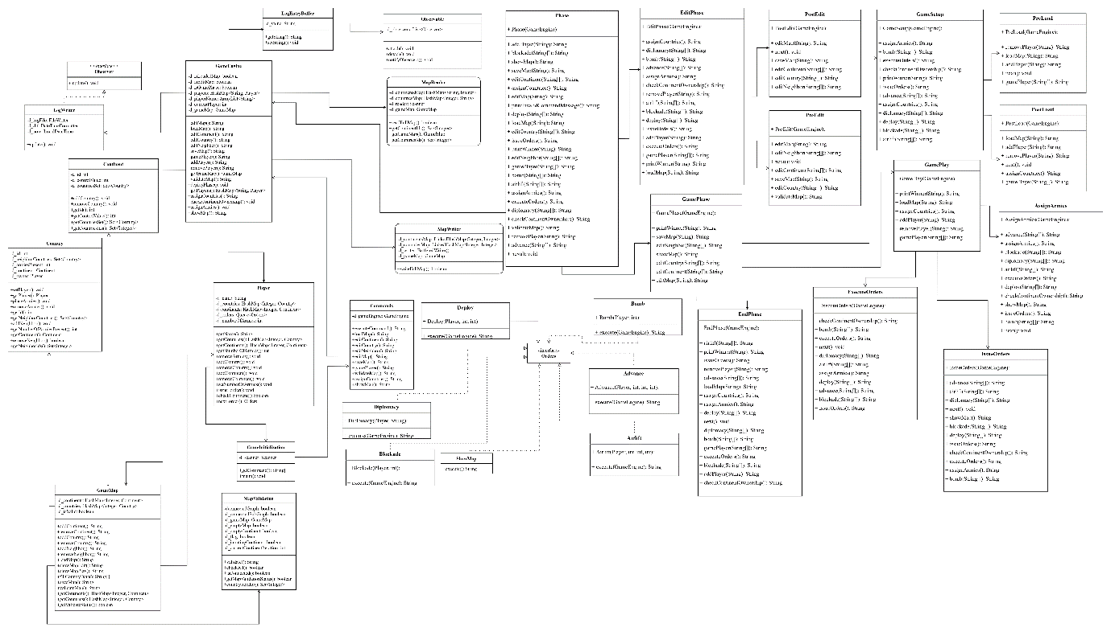

**Description:**

**Class Commands:**

This Class is used to execute all commands by user which are fetched from GameInitialization Class.

**Class GameInitialization:**

This class is used to get user commands and call executeCommand() in Commands Class.

**Class GameEngine:**

This class is used to handle most part of the game. It is controller of the game and all the operations will execute from this class.

**Class Country:**

This class contains all details of country like ID, Continent, Neighbors, Owner, No. of Armies, etc.

**Class Continent:**

This class contains all details of continent like ID, Control Value, etc.

**Class Player:**

This class contains all details of player like name of player, ID, dominated Countries and Continents, No. of Armies, Orders etc.

**Class GameMap:**

This class is used to handle all the operations related to map like add/remove Countries and/or Continents, add/remove neighbors, load map, save map, etc.

**Class MapWriter:**

This class is used to write game map as text in map file.

**Class MapReader:**

This class is used to read data from map file.

**Class MapValidation:**

This class is used to validate map which is created by user, according to rules of the game.

**Class Deploy:**

This class is used to deploy armies according to orders issued by the player.

**Class ShowMap:**

This class is used to execute show map command at any time in the game.

**Interface Orders:**

This interface provides structure for execute order.

**Class LogEntryBuffer:**

This will inherit Observable class whose function is to obtain the outputs that are obtained after executing commands.

**Class LogWriter:**

This class will inherit Observer and whose function is to write the output to the log file.

**Class Observable:**

This Class will implement the connection/disconnection mechanism between observers and observables (subject). It also implements the notification mechanism that the observable will trigger when its state changes.

**Interface Observer:**

Interface Observer, which forces all views to implement the update method.

**Class Phase:**

An abstract class for the Phase implementation of state pattern.

**Class EditPhase:**

The EditPhase class is inherited from the Phase class to support commands valid in editing phase.

**Class PostEdit:**

The PostEdit class is inherited from the EditPhase class to support commands valid in post editing phase.

**Class PreEdit:**

The PreEdit class is inherited from the EditPhase class to support commands valid in pre editing phase.

**Class GamePhase:**

The GamePhase class is inherited from the Phase class to support commands valid in game phase (general commands).

**Class EndPhase:**

This is the class that inherits GamePhase class whose fucntion is to print the winner of the game.

**Class AssignArmies:**

AssignArmies class that inherits GamePlay class to support functions during this command.

**Class GamePlay:**

GamePlay class that inherits GamePhase to support gameplay compatible commands.

**Class ExecuteOrders:**

ExecuteOrder class that inherits GamePlay class to support functions during this command.

**Class IssueOrders:**

IssueOrder class that inherits GamePlay class to support functions during this command.

**Class GameSetup:**

Abstract class of game setup the represents the initial process of entering the gameplay.

**Class PostLoad:**

This class will setup the game before game load.

**Class PreLoad:**

This class will do necessary steps after game load.

**Class Bomb:**

This class will execute order given by user to place Bomb Card on specified country. This card will destroy 50% army of country.

**Class Blocakde:**

This class will execute order given by user to place Blockade Card on specified country. This card will increase army by 3 times and assign owner as a Neutral Player.

**Class Airlift:**

This class will execute order given by user to place Airlift Card on specified country. This card will transfer specified number of amies from one country to other.

**Class Advance:**

This class will execute Advance order given by user on specified country. This will transfer specified no. of amies from one country to other if player owns the country otherwise it will attack with specified armies.

**Class Diplomacy:**

This class will execute order given by user to place Diplomacy Card on specified country. This card will be used to negotiate between two players so that neither can attack on each other during their turn.